Virginia State Simulation Alliance (VASSA) Regional Meeting

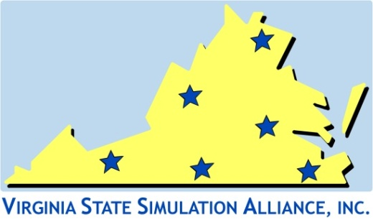
Agenda

7/31/2017

- Call to Order
- The meeting was called to order by Angelic Sorrell.
- Amending of Agenda
- None
- Approval of Minutes
- Deferred. Minutes were not available.
- Reports-Updates/Discussion

- There will be a mini-SUN on November 6th in Lynchburg
- There are currently multiple job openings in the Capital Region for simulation faculty and techs.
- There are several new simulation users in the area who are in need of mentoring and training in basic simulation implementation. Classes to support their new roles are requested.

- Discussion- What are the trends in simulation?
- There is an increased need for both OB and psych simulation scenarios related to decrease access to these clinical sites.
- There is an increasing expectation to offer interprofessional simulation.
- Some health professions are requiring competency-based assessment as part of credentialing. The National League for Nursing is researching this process for nursing.

- Needs Assessment- Future conference topics
- Track specific to attendees new to simulation
- Track for those with 2-3 years in simulation
- Sessions for new simulation users on running simulation—both standardized and ‘on the fly’
- Resources for pre-made/modifiable scenarios
- Regional workshops on the basic use and implementation of simulation for new members

- Membership
- Members of the Capitol Region were asked to encourage colleagues to join VASSA for local resources and a lower cost to attend the annual VASSA conferences.
- Membership fees are $50.00/year (January-December)

- Next Regional Meeting date discussed & Adjournment
- Notification of the next regional meeting will be sent out via email by Nancy Leahy.

- Reminder to attend General VASSA Membership meeting on 8/1
- Attendees were encouraged to attend the membership meeting on 8/1 at 12:40.
- Other
- None
The meeting was adjourned by Angelic Sorrell at 1:35 pm.

Virginia State Simulation Alliance (VASSA)

